Mathematical Modeling Activity

Viral Spread
NAME: _____________________

Instructions:
This document is used to record your answers. Write your answers here, embed your images where necessary and then submit this document to Canvas.
Part 1: Based on what you’ve heard or know about viruses and your knowledge of growth, what type of growth do you think usually described epidemics – exponential, logarithmic, or linear? Please give basic definitions for the different growth models and explain the reasons for your choice.
Exponential growth
This is because considering the epidemics growth in China, according to the positive cases of COVID-19 report in China since January to March. The graph below shows the analysis of the opinion of union health ministry of China.
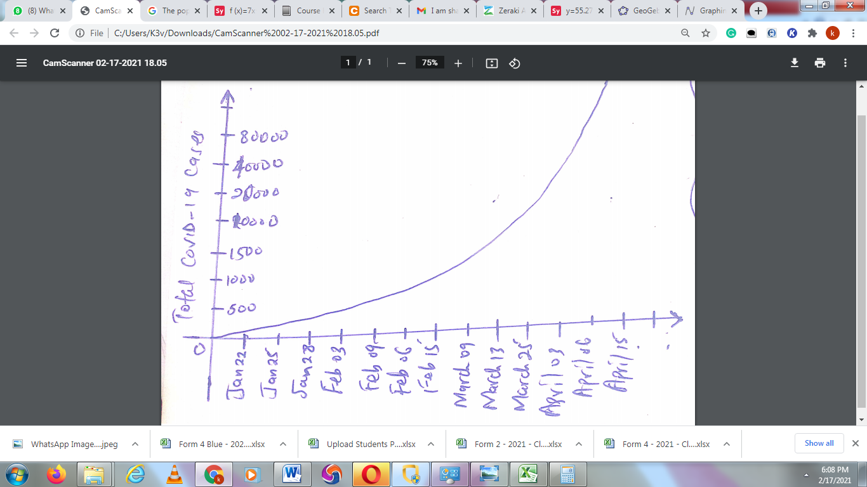
There is a sudden growth from January to April.
Growth resembles an exponential function.
The graph below is an exponential function curve.
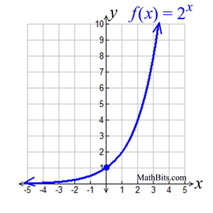

Part 2: Below is data of the weekly number of suspected Zika cases in French Polynesia in 2013. Using GeoGebra, make a scatter plot of the data where the horizontal axis is week number and the vertical access is the cumulative cases of Zika.
Week # | New Cases | Cumulative Cases
1 | 49 | 49
2 | 191 | 240
3 | 369 | 609
4 | 331 | 940
5 | 333 | 1273
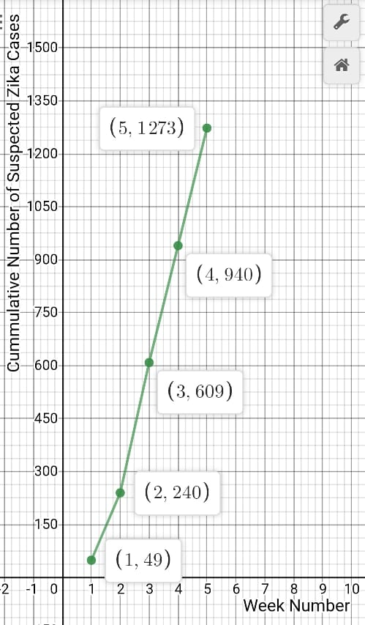
Part 3: Does your answer from Part 1 fit the shape of the scatter plot from Part 2? What does the shape of the scatter plot tell you about the type of growth that occurred with the first 5 weeks of the spread of the Zika virus? Please explain.
The exponential curve from part 1 fits the shape of the scatter plot from part 2.
From the shape of the scatter plot, there exists an increase in the number of suspected Zika classes as the number of weeks increase.
There is a positive correlation between the number of weeks and the number of suspected Zika classes.

Part 4: Here are two different functional models that might represent the growth of the number of Zika cases, where x represents the week number, and y represents the number of cumulative cases.
1. Linear: $y=258.74x$
2. Exponential: $y=55.278x^{2.0101}$.
For each function model listed, create a graph for 1 ≤ x ≤ 5, along with the Zika case data. This means that you will include 2 images from Geogebra to this document. Be sure your graphs are clearly labeled including the function and the actual data.
1. Linear: $y=258.74x$

2. Exponential: $y=55.278x^{2.0101}$.

Part 5: Which of the graphs from Part 4 do you think best models the Zika data? Why?
Exponential: $y=55.278x^{2.0101}$
This graph shows an exponential relationship as depicted by the Zika data
Part 6: Below is the actual data for the spread of Zika during weeks 1 – 10 of the epidemic. Add the data points for weeks 6 – 10 to your graphs. Extend the graphs of the functions and look at the interval $0≤x≤10$.

Which of these functions will be the best model the growth of Zika cases over weeks 6 – 10? Is this the same function that you chose in question 2? If not, what caused you to change your mind? Please include an image here of the graph that you have chosen for the best model. You will use GeoGebra to create the image of this graph, and paste that graph here.
Exponential: $y=55.278x^{2.0101}$ will be the best model the growth of Zika cases over weeks 6 – 10. This is because it shows continued positive correlation between the number of weeks and the number of suspected Zika cases.

Week # | New Cases | Cumulative Cases
1 | 49 | 49
2 | 191 | 240
3 | 369 | 609
4 | 331 | 940
5 | 333 | 1273
6 | 571 | 1844
7 | 742 | 2586
8 | 955 | 3541
9 | 1029 | 4570
10 | 883 | 5453

Part 7: The population of French Polynesia at the time of the outbreak was about 270,000. The population of the United States in 2016 was approximately 322,762,000. How could you modify your function to model a potential spread of the Zika virus over the United States?
Remove the outliers in the model which will make it predict with high level of accuracy in the united states.

Part 8: (DISCUSSION FOUND ON CANVAS) Discuss the pros and cons of using your modified Zika function model for French Polynesia as a model for the United States. In your original post (only one post per group), please list at least two pros and two cons, please use mathematical reasoning in your discussion. Make your original post by Wednesday at midnight. Individually respond to at least two threads, in your responses please respond to their reasoning. As always please be polite and respectful in all interactions.

Submissions:
- Submit Parts 1 - 7 using this WORD DOCUMENT. Open the WORD DOCUMENT and answer the questions, include your graphs and charts in your submissions. Once you have written everything up, you will submit your word document by clicking "Submit" in the upper right corner of this screen.
- Submit your group's discussion post (FOUND IN CANVAS) by Wednesday at midnight to the discussion board in Canvas. Please respond, individually, to at least two groups posts by Sunday at midnight.

